Nama : Juan Felix Parsaoran Tarigan

Latihan Sesi 12

Latihan 1: Database Melodi Indah

* **ER Diagram**

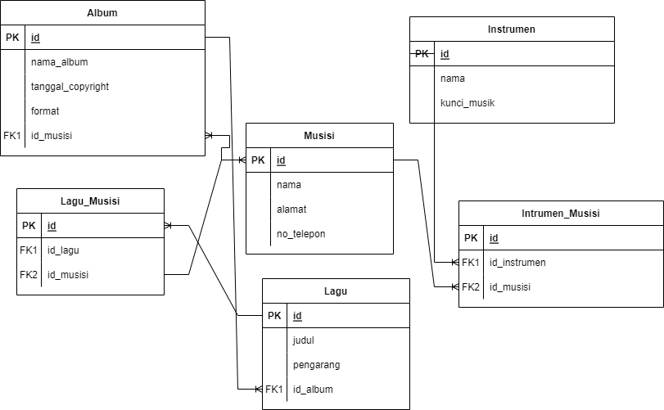

Gambar 1 : ER Diagram database melodi indah

* **Create and Insert Database**

-- Adminer 4.8.1 MySQL 10.4.24-MariaDB dump

SET NAMES utf8;

SET time_zone = '+00:00';

SET foreign_key_checks = 0;

SET sql_mode = 'NO_AUTO_VALUE_ON_ZERO';

SET NAMES utf8mb4;

DROP TABLE IF EXISTS `album`;

CREATE TABLE `album` (

`id` int(11) NOT NULL AUTO_INCREMENT,

`nama_album` varchar(255) NOT NULL,

`tanggal_copyright` date NOT NULL,

`format` enum('CD','MC') NOT NULL,

`id_musisi` int(11) NOT NULL,

PRIMARY KEY (`id`),

KEY `id_musisi` (`id_musisi`),

CONSTRAINT `album_ibfk_1` FOREIGN KEY (`id_musisi`) REFERENCES `musisi` (`id`)

) ENGINE=InnoDB DEFAULT CHARSET=utf8mb4;

INSERT INTO `album` (`id`, `nama_album`, `tanggal_copyright`, `format`, `id_musisi`) VALUES

(1, 'Kenangan', '2022-06-21', 'CD', 1),

(2, 'Jalan-Jalan', '2022-06-21', 'MC', 2),

(3, 'Kali Keseratus', '2022-06-21', 'CD', 3),

(4, 'Terjebak Jalan', '2022-06-21', 'CD', 4),

(5, 'Pop Rock', '2022-06-21', 'CD', 5);

DROP TABLE IF EXISTS `instrumen`;

CREATE TABLE `instrumen` (

`id` int(11) NOT NULL AUTO_INCREMENT,

`nama` varchar(255) NOT NULL,

`kunci_musik` varchar(255) NOT NULL,

PRIMARY KEY (`id`)

) ENGINE=InnoDB DEFAULT CHARSET=utf8mb4;

INSERT INTO `instrumen` (`id`, `nama`, `kunci_musik`) VALUES

(1, 'Gitar', 'C'),

(2, 'Suling', 'F'),

(3, 'Keyboard', 'E#'),

(4, 'Drum', '');

DROP TABLE IF EXISTS `instrumen_musisi`;

CREATE TABLE `instrumen_musisi` (

`id` int(11) NOT NULL,

`id_instrumen` int(11) NOT NULL,

`id_musisi` int(11) NOT NULL,

KEY `id_instrumen` (`id_instrumen`),

KEY `id_musisi` (`id_musisi`),

CONSTRAINT `instrumen_musisi_ibfk_1` FOREIGN KEY (`id_instrumen`) REFERENCES `instrumen` (`id`),

CONSTRAINT `instrumen_musisi_ibfk_2` FOREIGN KEY (`id_musisi`) REFERENCES `musisi` (`id`)

) ENGINE=InnoDB DEFAULT CHARSET=utf8mb4;

INSERT INTO `instrumen_musisi` (`id`, `id_instrumen`, `id_musisi`) VALUES

(0, 1, 2),

(0, 4, 1),

(0, 1, 3),

(0, 2, 4),

(0, 3, 3);

DROP TABLE IF EXISTS `lagu`;

CREATE TABLE `lagu` (

`id` int(11) NOT NULL AUTO_INCREMENT,

`judul` varchar(255) NOT NULL,

`pengarang` varchar(255) NOT NULL,

`id_album` int(11) NOT NULL,

PRIMARY KEY (`id`),

KEY `id_album` (`id_album`),

CONSTRAINT `lagu_ibfk_2` FOREIGN KEY (`id_album`) REFERENCES `album` (`id`)

) ENGINE=InnoDB DEFAULT CHARSET=utf8mb4;

INSERT INTO `lagu` (`id`, `judul`, `pengarang`, `id_album`) VALUES

(1, 'Cekmic', 'John', 1),

(2, 'Sampai Jumpa', 'Nune', 2),

(3, 'Loop', 'Turing', 3),

(4, 'Kotak', 'Teh', 4),

(5, 'Moni', 'Tor', 5),

(6, 'Paper', 'Pen', 1),

(7, 'Money', 'Money', 3),

(8, 'Plate', 'Spoon', 5);

DROP TABLE IF EXISTS `lagu_musisi`;

CREATE TABLE `lagu_musisi` (

`id` int(11) NOT NULL AUTO_INCREMENT,

`id_musisi` int(11) NOT NULL,

`id_lagu` int(11) NOT NULL,

PRIMARY KEY (`id`),

KEY `id_musisi` (`id_musisi`),

KEY `id_lagu` (`id_lagu`),

CONSTRAINT `lagu_musisi_ibfk_1` FOREIGN KEY (`id_musisi`) REFERENCES `musisi` (`id`),

CONSTRAINT `lagu_musisi_ibfk_2` FOREIGN KEY (`id_lagu`) REFERENCES `lagu` (`id`)

) ENGINE=InnoDB DEFAULT CHARSET=utf8mb4;

INSERT INTO `lagu_musisi` (`id`, `id_musisi`, `id_lagu`) VALUES

(1, 1, 8),

(2, 2, 8),

(3, 2, 1),

(4, 3, 2),

(5, 4, 3),

(6, 5, 5),

(7, 4, 5),

(8, 3, 6),

(9, 2, 7),

(10, 2, 7);

DROP TABLE IF EXISTS `musisi`;

CREATE TABLE `musisi` (

`id` int(11) NOT NULL AUTO_INCREMENT,

`nama` varchar(255) NOT NULL,

`alamat` varchar(255) DEFAULT NULL,

`no_telepon` varchar(255) NOT NULL,

PRIMARY KEY (`id`)

) ENGINE=InnoDB DEFAULT CHARSET=utf8mb4;

INSERT INTO `musisi` (`id`, `nama`, `alamat`, `no_telepon`) VALUES

(1, 'Juan', 'Bandung', '082738182939'),

(2, 'Peng', 'Medan', '082928382938'),

(3, 'Chris', 'Jakarta', '08294182944'),

(4, 'Jay', 'Jogja', '08536273812'),

(5, 'Cobis', 'Pekanbaru', '08738284729');

-- 2022-06-21 07:08:01

Latihan 2 : Database Company

* **ER Diagram**

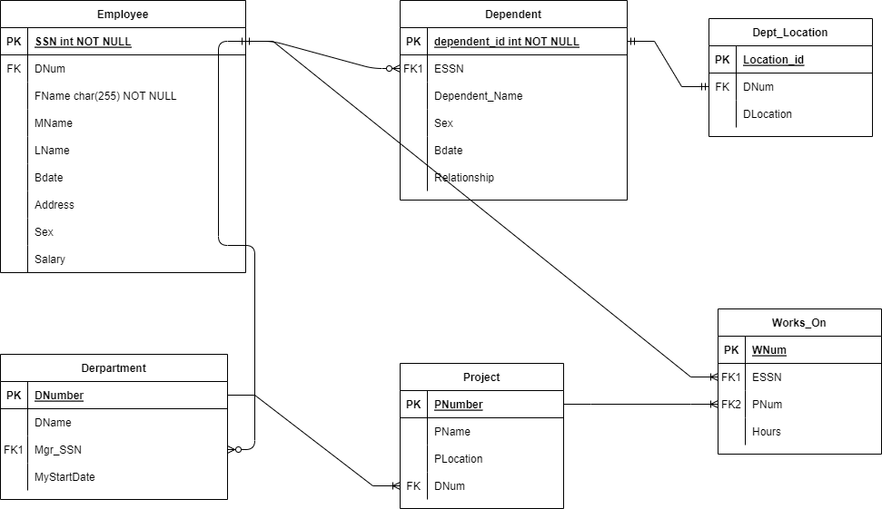

Gambar 2. ER Diagram Company

* **Create and Insert Database**

-- Adminer 4.8.1 MySQL 10.4.24-MariaDB dump

SET NAMES utf8;

SET time_zone = '+00:00';

SET foreign_key_checks = 0;

SET sql_mode = 'NO_AUTO_VALUE_ON_ZERO';

SET NAMES utf8mb4;

DROP TABLE IF EXISTS `department`;

CREATE TABLE `department` (

`DNumber` int(11) NOT NULL AUTO_INCREMENT,

`DName` varchar(255) NOT NULL,

`MgrSSN` int(11) NOT NULL,

`MgrStartDate` date NOT NULL,

PRIMARY KEY (`DNumber`),

KEY `MgrSSN` (`MgrSSN`),

CONSTRAINT `department_ibfk_1` FOREIGN KEY (`MgrSSN`) REFERENCES `employee` (`SSN`)

) ENGINE=InnoDB DEFAULT CHARSET=utf8mb4;

INSERT INTO `department` (`DNumber`, `DName`, `MgrSSN`, `MgrStartDate`) VALUES

(3, 'Finance', 6, '2020-07-01'),

(4, 'IT', 7, '2021-01-21'),

(5, 'HR', 16, '2021-06-20');

DROP TABLE IF EXISTS `dependent`;

CREATE TABLE `dependent` (

`id` int(11) NOT NULL AUTO_INCREMENT,

`ESSN` int(11) NOT NULL,

`dependent_name` varchar(255) NOT NULL,

`sex` enum('male','female') NOT NULL,

`Bdate` date NOT NULL,

`relationship` varchar(255) NOT NULL,

PRIMARY KEY (`id`),

KEY `ESSN` (`ESSN`),

CONSTRAINT `dependent_ibfk_1` FOREIGN KEY (`ESSN`) REFERENCES `employee` (`SSN`)

) ENGINE=InnoDB DEFAULT CHARSET=utf8mb4;

INSERT INTO `dependent` (`id`, `ESSN`, `dependent_name`, `sex`, `Bdate`, `relationship`) VALUES

(1, 6, 'Uti', 'female', '2022-06-21', 'spouse'),

(2, 7, 'Mun', 'female', '2022-06-21', 'brother'),

(3, 7, '', 'male', '2022-06-21', 'brother'),

(4, 8, 'Mon', 'male', '2022-06-21', 'father'),

(5, 15, 'Jan', 'female', '2022-06-21', 'spouse');

DROP TABLE IF EXISTS `dept_location`;

CREATE TABLE `dept_location` (

`id` int(11) NOT NULL AUTO_INCREMENT,

`DNum` int(11) NOT NULL,

`DLocation` varchar(255) NOT NULL,

PRIMARY KEY (`id`),

KEY `DNum` (`DNum`),

CONSTRAINT `dept_location_ibfk_1` FOREIGN KEY (`DNum`) REFERENCES `department` (`DNumber`)

) ENGINE=InnoDB DEFAULT CHARSET=utf8mb4;

INSERT INTO `dept_location` (`id`, `DNum`, `DLocation`) VALUES

(1, 3, 'Head Office'),

(2, 4, 'Head Office'),

(3, 5, 'Jakarta');

DROP TABLE IF EXISTS `employee`;

CREATE TABLE `employee` (

`SSN` int(11) NOT NULL AUTO_INCREMENT,

`FName` varchar(255) NOT NULL,

`MName` varchar(255) NOT NULL,

`LName` varchar(255) NOT NULL,

`Bdate` date NOT NULL,

`Address` varchar(255) NOT NULL,

`Sex` enum('male','female') NOT NULL,

`Salary` int(11) NOT NULL,

`DNum` int(11) NOT NULL,

PRIMARY KEY (`SSN`),

KEY `DNum` (`DNum`),

CONSTRAINT `employee_ibfk_1` FOREIGN KEY (`DNum`) REFERENCES `department` (`DNumber`)

) ENGINE=InnoDB DEFAULT CHARSET=utf8mb4;

INSERT INTO `employee` (`SSN`, `FName`, `MName`, `LName`, `Bdate`, `Address`, `Sex`, `Salary`, `DNum`) VALUES

(6, 'Ron', 'Jun', 'Doe', '2022-06-21', 'Jakarta', 'male', 70000000, 3),

(7, 'Jin', 'Jun', 'Doe', '2022-06-21', 'Bandung', 'male', 10000000, 4),

(8, 'Tar', '', 'Tir', '2022-06-21', 'Medan', 'female', 12000000, 4),

(9, 'Peng', '', '', '2022-06-21', 'Cimahi', 'male', 36000000, 3),

(11, 'Cobis', '', '', '2022-06-21', 'Jakarta', 'male', 20000000, 5),

(12, 'Chris', '', '', '2022-06-21', '', 'male', 10000000, 3),

(13, 'Jay', '', '', '2022-06-21', 'Medan', 'male', 3000000, 3),

(14, 'Nal', '', '', '0000-00-00', 'Medan', 'male', 15000000, 4),

(15, 'Kucrut', '', '', '0000-00-00', 'Bandung', 'male', 20000000, 5),

(16, 'Juan', '', '', '0000-00-00', '', 'male', 100000000, 5);

DROP TABLE IF EXISTS `project`;

CREATE TABLE `project` (

`PNumber` int(11) NOT NULL AUTO_INCREMENT,

`PName` varchar(255) NOT NULL,

`PLocation` varchar(255) NOT NULL,

`DNum` int(11) NOT NULL,

PRIMARY KEY (`PNumber`),

KEY `DNum` (`DNum`),

CONSTRAINT `project_ibfk_1` FOREIGN KEY (`DNum`) REFERENCES `department` (`DNumber`)

) ENGINE=InnoDB DEFAULT CHARSET=utf8mb4;

INSERT INTO `project` (`PNumber`, `PName`, `PLocation`, `DNum`) VALUES

(1, 'BTDP', 'Jakarta', 5),

(2, 'Develop Web', 'Jakarta', 4),

(3, 'Cut Cost', 'Jakarta', 3),

(4, 'Test Project', 'Bandung', 3);

DROP TABLE IF EXISTS `works_on`;

CREATE TABLE `works_on` (

`id` int(11) NOT NULL AUTO_INCREMENT,

`ESSN` int(11) NOT NULL,

`PNumber` int(11) NOT NULL,

`hours` int(11) NOT NULL,

PRIMARY KEY (`id`),

KEY `ESSN` (`ESSN`),

KEY `PNumber` (`PNumber`),

CONSTRAINT `works_on_ibfk_1` FOREIGN KEY (`ESSN`) REFERENCES `employee` (`SSN`),

CONSTRAINT `works_on_ibfk_2` FOREIGN KEY (`PNumber`) REFERENCES `project` (`PNumber`)

) ENGINE=InnoDB DEFAULT CHARSET=utf8mb4;

INSERT INTO `works_on` (`id`, `ESSN`, `PNumber`, `hours`) VALUES

(2, 6, 1, 100),

(3, 8, 1, 150),

(5, 16, 1, 200),

(6, 6, 2, 160),

(7, 15, 2, 250),

(8, 13, 2, 100),

(9, 16, 1, 120),

(10, 6, 3, 110),

(11, 16, 3, 100);

-- 2022-06-21 07:30:29

* **Soal Query**

1. Tampilkan dependent_name dan relationship dengan employee yang namanya diawali huruf R

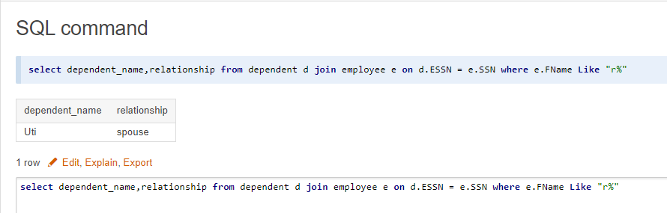

Gambar 3. Query dan hasil query soal a.

1. Banyaknya employee yang mengerjakan projek PNum=1

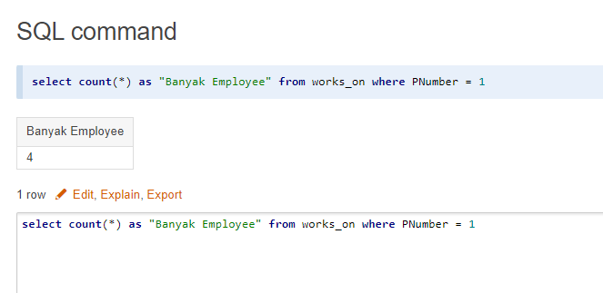

Gambar 4. Query dan hasil query soal b

1. Banyaknya employee yang memiliki salary lebih dari 35 juta

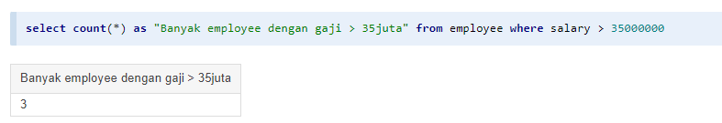

Gambar 5. Query dan hasil query soal c

1. Banyaknya project yang dikerjakan DNum=3

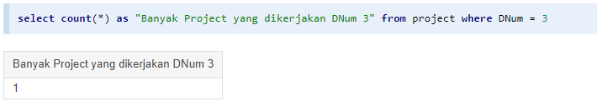

Gambar 6. Query dan hasil query soal d

1. Hitung total dan rata-rata salary pada setiap departemen

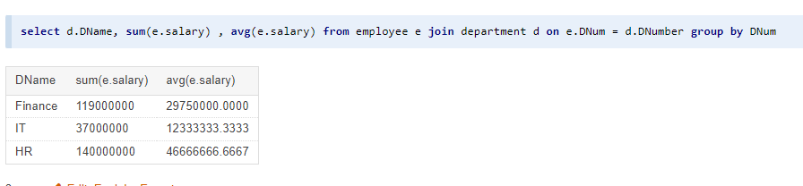

Gambar 7. Query dan hasil query soal e

1. Banyaknya employee dari setiap departemen dan urutkan berdasarkan employee terbanyak

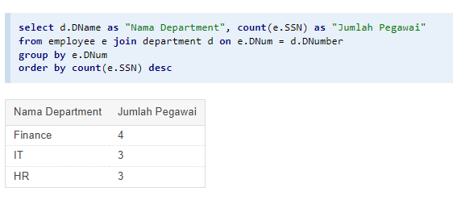

Gambar 8. Query dan hasil query soal f

1. Total hours perweek dari semua employee di setiap proyek

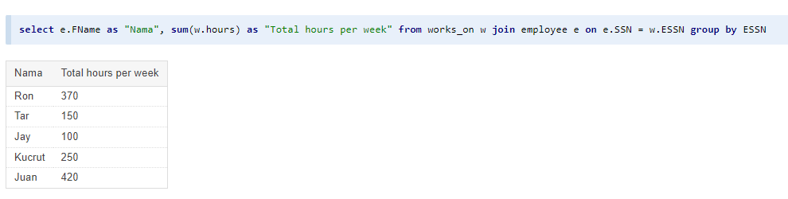

Gambar 9. Query dan hasil query g

1. Employee yang memiliki total hours >140 dan urutkan berdasarkan jumlah kerja terbanyak

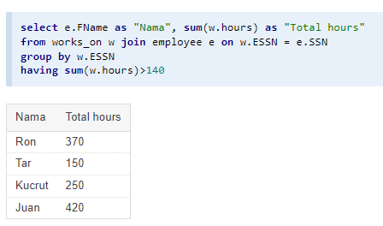

Gambar 10. Query dan hasil query soal h

1. Kelompokkan bonus employee
2. Banyaknya project yang dikerjakan tiap employee dan urutkan dari yang terbanyak

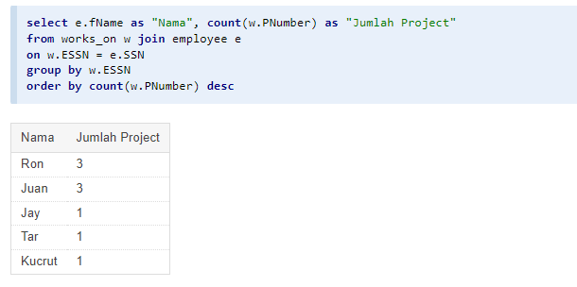

Gambar 12. Query dan hasil query soal j

1. Employee yang bekerja pada 3 project

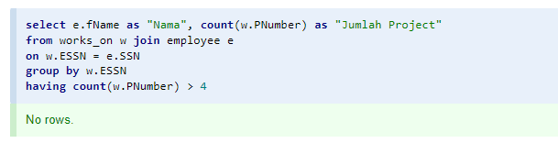

Gambar 13. Query dan hasil query soal k

1. Employee yang memiliki rata-rata hours > 70 jam dan bekerja pada 2 project

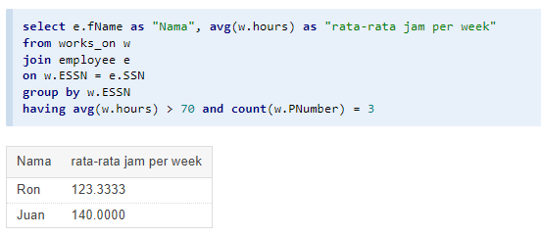

Gambar 14. Query dan hasil query soal l

1. Banyaknya dependent berdasarkan relationship

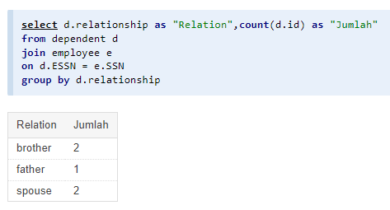

Gambar 15. Query dan hasil query soal m

1. Berapa lama manager tiap departemen sudah menjabat

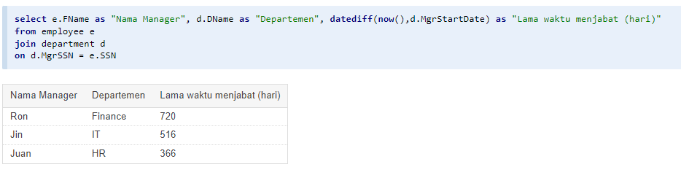

Gambar 16. Query dan hasil query soal n

1. Lokasi project yang digunakan oleh lebih dari satu departemen



Gambar 17. Query dan hasil query soal o